Load Pin Quotation Request
Please complete the information below to enable us to make a suitable quotation for your requirements:
Contact Details
Contact Name: | Click here to enter text.
Designation: | Click here to enter text.
Company: | Click here to enter text.
Country: | Click here to enter text.
Email: | Click here to enter text.
Phone: | Click here to enter text.

Application Information
Application Description: |  |  | Click here to enter text.
Measurement Range (tonnes): |  |  | Click here to enter text.
Rated Output (mV/V): |  |  | Click here to enter text.
Breaking Load (tonnes); |  |  | Click here to enter text.
Operating Temperature: | Min °C |  | Click here to enter text.
 | Max °C |  | Click here to enter text.
Sealing (IP rating): |  |  | Click here to enter text.
Dimensions
Please either supply a drawing of your existing pin or complete the dimension table below.
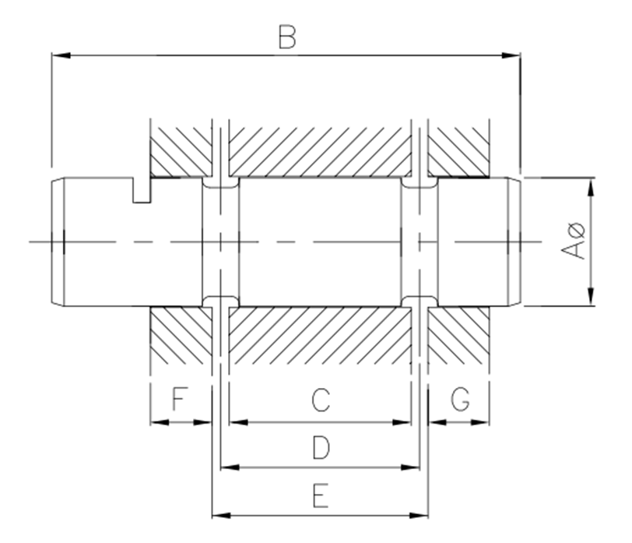
Diameter A is a critical measurement for best pin performance and should be measured accurately using an existing non-worn/corroded pin, an existing drawing, or obtained from the original pin manufacturer. Tolerance on this diameter should also be provided where known.Tolerances on other dimensions are less critical but should be included if known.
Note: Tolerance of +0.00 / -0.05 mm will be considered. Unless expressly requested.
Dimension |  | mm |  | Tolerance + mm | Tolerance - mm
øA |  | Click here to enter text. |  | Click here to enter text. | Click here to enter text.
B |  | Click here to enter text. |  | Click here to enter text. | Click here to enter text.
C |  | Click here to enter text. |  | Click here to enter text. | Click here to enter text.
D |  | Click here to enter text. |  | Click here to enter text. | Click here to enter text.
E |  | Click here to enter text. |  | Click here to enter text. | Click here to enter text.
F |  | Click here to enter text. |  | Click here to enter text. | Click here to enter text.
G |  | Click here to enter text. |  | Click here to enter text. | Click here to enter text.

Load Pin Locking Arrangement
Please indicate which locking arrangement you require
Single Diameter Style |  |  | Terminal Housing Style
above | ☐ | 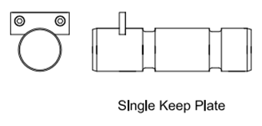 | above | ☐ | 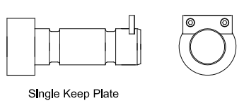
below | ☐ |  | below | ☐
above | ☐ | 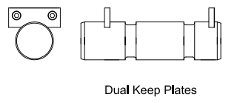 | above | ☐ | 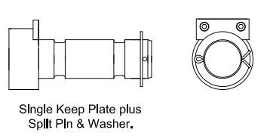
below | ☐ |  | below | ☐
 |  | 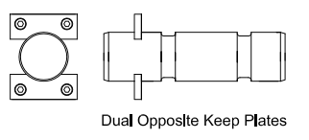 | above | ☐ | 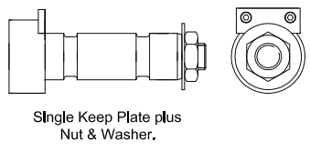
 |  |  | below | ☐
If you require a locking arrangement which is different to any of those shown, please supply a drawing of your requirement. |  |  | above | ☐ | 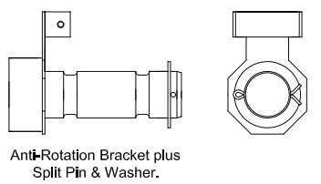
 |  |  | below | ☐

Load Pin Cable Arrangement
Please indicate which cable arrangement you require
Fixed Cable |  |  |  | Connector
right | ☐ | 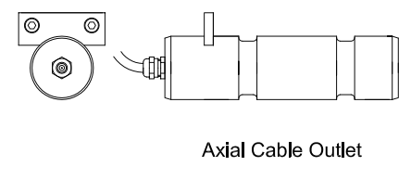 |  | right |  | ☐ | 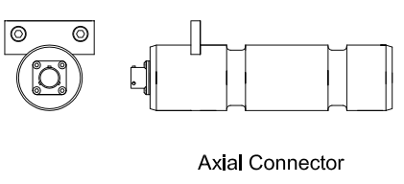
left | ☐ |  |  | left |  | ☐
right | ☐ | 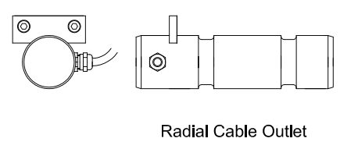 |  | right |  | ☐ | 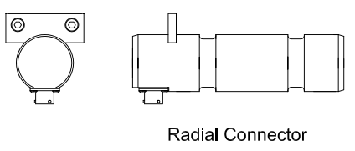
left | ☐ |  |  | left |  | ☐
If you require a cable arrangement which is different to any of those shown, please supply a drawing of your requirement. |  |  |  | right |  | ☐ | 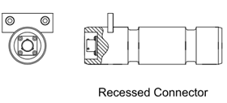
 |  |  |  | left |  | ☐
Output Signal
Please indicate what type of output signal you require
mV/V output (4 wire) |  |  | ☐ |  | 4-20mA output |  |  | ☐
0-10V output |  |  | ☐
For other output please specify your requirement:
Click here to enter text.

Redundant Output (Optional)
☐ YES, 2 electrical circuit, independent of each. 1 output cable of 8 wires
☐ YES, 2 electrical circuit, independent of each other. 2 Output cable of 4 wires
☐ NO

Lubrication holes (Optional)
☐ YES (please provide the drawing)
☐ NO

ATEX (Optional)
☐ YES
☐ NO

Please send this completed quotation request form to: sales@thames-side.in

